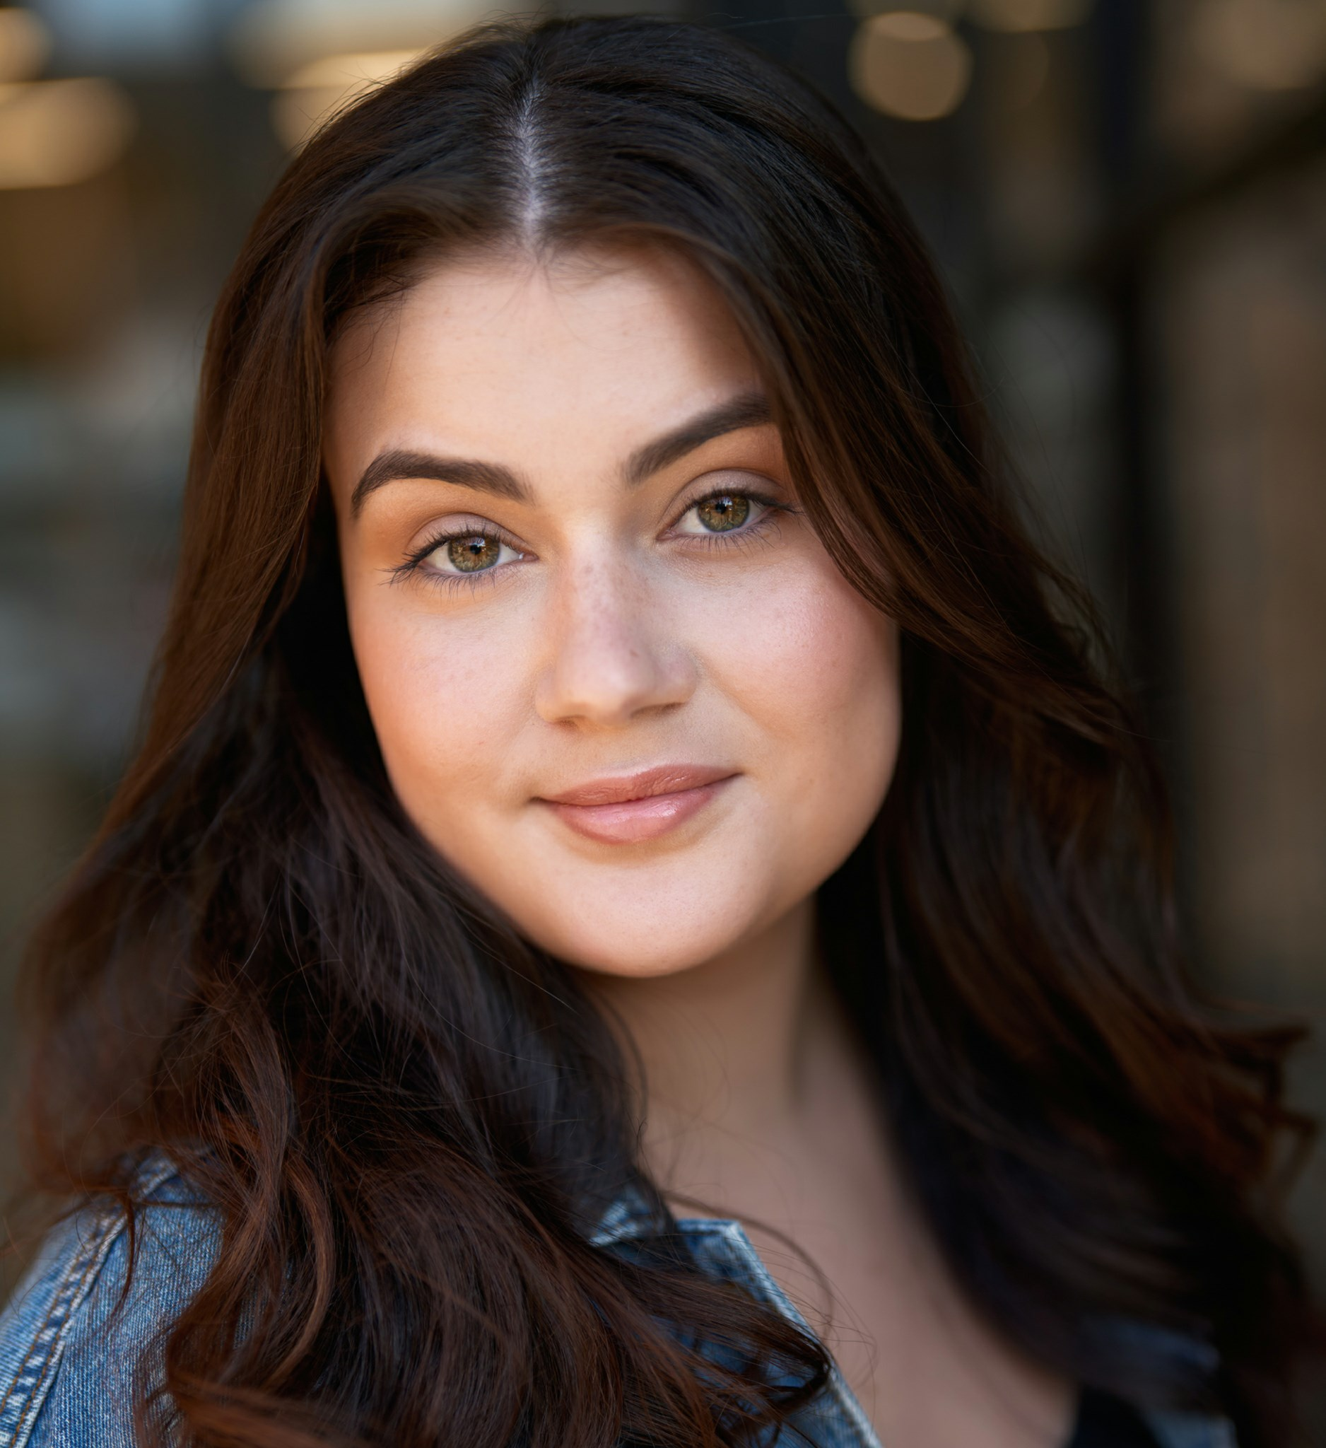 | RENEE OBRIEN  C O N T A C T  Phone 0408 373 139  Email admin@khansentertainment.com.au  Agent Khans Entertainment Agency  Web www.khansentertainment.com  Base Melbourne, VIC, Australia

HEIGHT | HAIR | EYES | AVAILABLE
165 cm | Brown | Hazel | Australia & International
ABOUT
Melbourne-based actor trained full-time at JMC Academy and TV & Film International. Alongside her acting training she also studied dance, focusing on ballet and contemporary work. She has since continued to develop her craft through scene study with Lachy Hulme, text work with Eve Morey, and accent and dialect training with Tyler Coppin. She brings an aliveness to her work, with a natural capacity for deep emotional states and genuine listening.
EDUCATION
Year | Institution | Qualification
2023 | JMC Academy | Diploma of Creative Arts (Acting)
2024 | TV & Film International | Full Time Acting for Television Program
TRAINING
Year | Institution / Coach | Course
2026 | Actors Lab | Screen Acting Program
2025 | Eve Morey | Text to Screen
2025 | Lachy Hulme | Scene Study Intensive
2024 | Tyler Coppin | American Accent & Dialect
2024 | Damian Walshe Howling | Practical Aesthetics
CREDITS
Role | Production | Director
Jenn Conner | Bound To | Dir. Nick Martin
Anna Moss | Fetas Tree | Dir. Candace Lindsay
Emma Pierce | Killjoy | Dir. Sam Payne
Anita Vale | The Sight | Dir. Lewis Hoareau
Sarah Harper | Coffee Crush | Dir. Lucy Shacher
Vivian | Zealots | Dir. JMC Academy

